Homework Assignment 1:
Polynomial Calculator
- Objective
Implementing a processing system for single variable polynomials with integer coefficients.
For accomplishing this task, the Integrated Development Environment of choice was Eclipse and it has proven helpful for including the necessary assets for developing the application and setting up an environment for JUnit Testing. The application was designed to have a Graphical User Interface from the ground up and implemented in such a way to provide a fool proof end-user app used to perform various operations on polynomials with one variable and integer coefficients.
- Mathematical Context
Monomials
A monomial is a product between variables of non-negative integer powers and coefficients. Roughly speaking they are polynomials which have one term. (However mentioning this is relevant since they are used throughout the design of polynomials in the implementation of the project). In this case, monomials have one variable and can be represented as such:

A few examples of the valid formats of representation:

Polynomials
A polynomial is an expression consisting of variables and coefficients which only employs the operation of addition, subtraction, multiplication and non-negative integer exponents. This expression can be seen as a sum between one or more monomials. The sum of the previously mentioned monomials would form the polynomial:

Polynomial operations
Polynomials support a set of operations. Since they are a sum of monomials, polynomials sum, subtraction, negation, multiplication with a polynomial and a scalar is trivial, using the respective operators' distributive property. Differentiation and integration pose no problem since they are trivial on monomials. The only operation which needs repeated steps to provide more than partial support is division.
The polynomial operations supported here:
  - Polynomial Addition
  - Polynomial Subtraction
  - Polynomial Multiplication
  - Polynomial Division
  - Polynomial Scalar Multiplication
  - Polynomial Differentiation
  - Polynomial Integration
Inferred model
In order to represent polynomials, a collection of Monomials has been employed. Monomials are represented by their coefficient and degree. The type of the degree is obviously an integer, however finding a suitable data type can be problematic: The aim is to imlement a system for processing one variable polynomials of integer coefficients. While the integer coefficients constraint can be applied by limiting the input options provided to the user, there are two operations that imply the division of coefficients: polynomial division and polynomial integration.
Because of these operations (which must be implemented in a basic polynomial processing system) the selected type must support some form of decimal capability. In the end the chosen type was BigDecimal since it supports all necessary operations and offers full control over the mathematical context (when dividing two BigDecimal values).
- Design
The project's aim is to develop an application which receives polynomials as input data and performs polynomial operations on them, outputting them afterwards.
Use case:
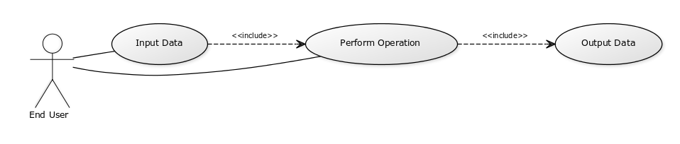
The application follows the Model-View-Controller design. To accomplish this, there are 3 packages named accordingly: model, view, controller.
Model package
Consists of the Polynomial class which uses a collection of Monomial, Polynomial Operation classes and PolynomialCalculator.
Polynomial Diagram:
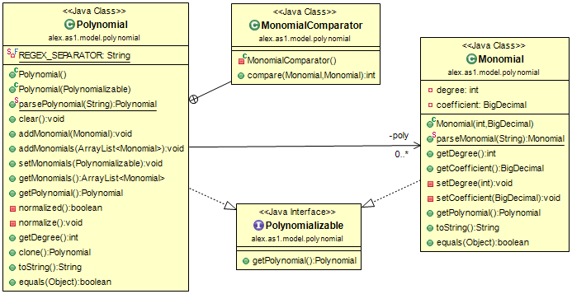
Monomial is a class that contains the necessary data to represent a monomial: a degree and a coefficient. It contains parseMonomial() as a static operation and it is used to interpret input data (from string to Monomial). It is important to note that this is the lowest level place where it is guaranteed that the coefficients are integer (at parsing, later transformed into BigDecimal). The only reason this type has to be used is the fact that polynomial division and polynomial integration can produce non-integer coefficients. Instead of choosing some arbitrary rule for them to produce only integer, the whole design was changed to support both exclusive integer input from the user and proper decimal representation in case it is needed.
Polynomial is basically a collection of Monomial. It can add monomials to it's own collection (either a Monomial or another collection of it). It can receive monomials in any order and of any degree – if there are multiple monomials having the same degree, it will break the format, therefor every time monomials get added it also calls normalize() in case what was obtained by adding monomials doesn't respect the normal form established by normalized() (which is: no two monomials of the same degree and monomials sorted with their degree descending). It contains parsePolynomial() which splits the String representing the polynomial into smaller Strings each representing a monomial using a regex established at data input. Then parses each individual Monomial and adds it into the polynomial collection. Note that the string passed in parsePolynomial() does not have to respect the normal form as long as the individual monomials are correct (ensured by the input protocol) since normalize() will take care of all your problems.
Polynomializable is an interface having getPolynomial() to bridge the connection between Monomial and Polynomial (Monomial is actually a polynomial). In their implementation, it returns a new object.

Operation Diagram:
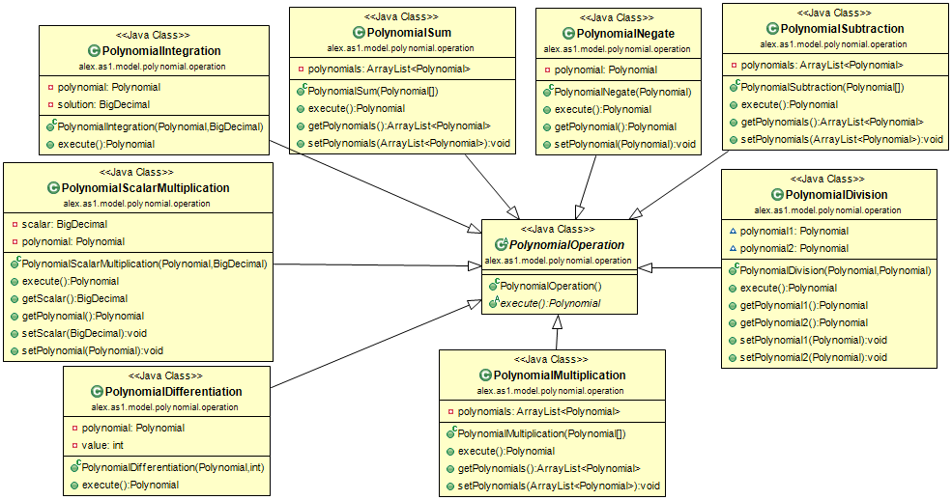
Polynomial Operations are implemented to fit a pattern. This is represented with inheritance. PolynomialOperation is a abstract class containing one method execute() which returns a Polynomial. This abstractions encompasses multiple types of operations: between two polynomials, between a polynomial and an integer and between a polynomial and a real number. Returning only one Polynomial is valid all but one operation, PolynomialDivision which exploits the fact that parameters may be altered (execute will return the quotient and the first parameter will become the remainder). The parameters for an operation are actually sent through the constructor of the respective class.
Polynomial Calculator
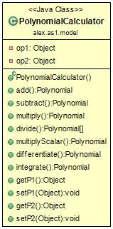
Polynomial Calculator class is the functional unit of the model. Its fields are Object since the operands' type may vary. It must be set with the correct operands for a specific operation then it may perform it. The operands are not changed during the operation but the output of the methods performing the operation is no longer streamlined to a Polynomial, it can also be a Polynomial array (two elements in case of polynomial division). It is the model part included in the controller.
View package
View Top Level:
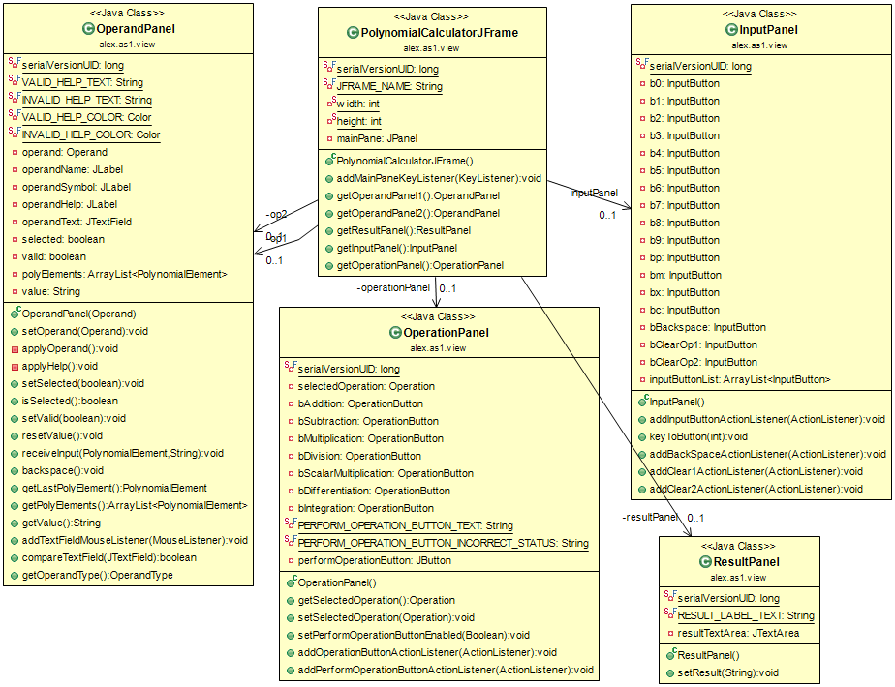
The view of the application, containing all graphical components and data holders for further interpretation is split into multiple classes extending visual elements. The Graphical User Interface is split into four panels:
- OperandPanel
- ResultPanel
- InputPanel
- OperationPanel

View Operand Panel:
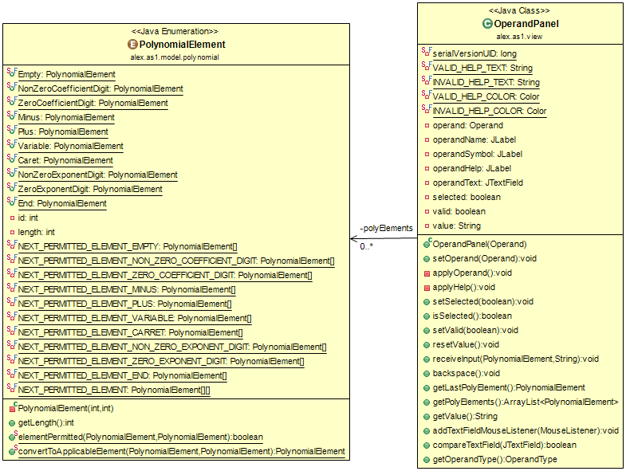
OperandPanel holds display information and provides feedback after the validity of the inserted input is checked. It holds the string value, which it keeps synchronized with the data on screen and a collection of PolynomialElement which is instrumental in determining the correctness of the format pre-parsing, since the parsing assumes the input corresponds the format.
Polynomial element is not a part of the view, but it is presented here since it is relevant. It contains the state a character that is inserted can have, and it uses a look-up table to check if a previous element admits the current one (Such as: you cannot start with a 0 or you cannot add a sign right after typing a ^, or the string cannot end with a ^).

View Result Panel:
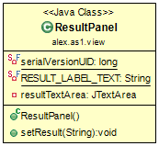
Result panel is the graphical item which will display the output of the performed operations.
View Input Panel:
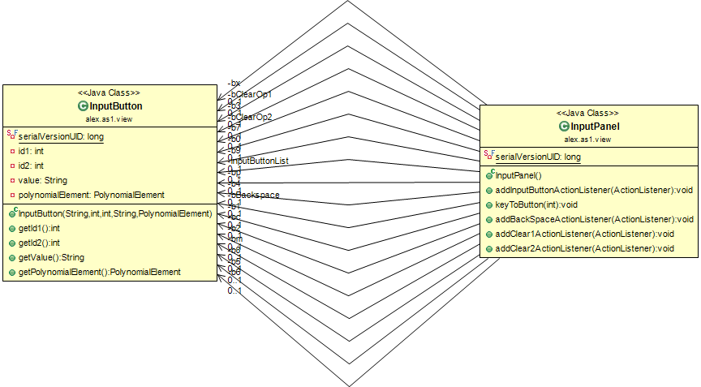
Input panel represents the only way to modify the data stored in Operand Panels. It uses InputButtons rather than JButtons in order to store data in them so only one listener is used for all of them (The listener extracts information form InputButton). And also to be able to redirect keyboard events to the button events (this is how this panel is the only way to change Operand Panels). The method keyToButton() receives the ID of the pressed key and searches through the buttons, firing an event to them if one has the same id.

View Operation Panel:
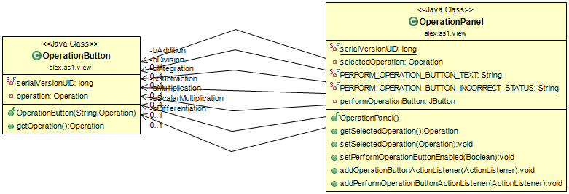
OperationPanel contains the selector buttons for the desired operation and also has the button to signal the controller to perform the opration. The buttons contain data about the operation so only one listener is used, also they extend JToggleButton and they belong to the same button group so only one of them stays pressed, and exactly one stays pressed down at all times. Pressing one triggers the event to change the displayed data on Operation Panels (all data contained by the buttons, in the operation enum).
Controller package
PolynomialCalculatorController:
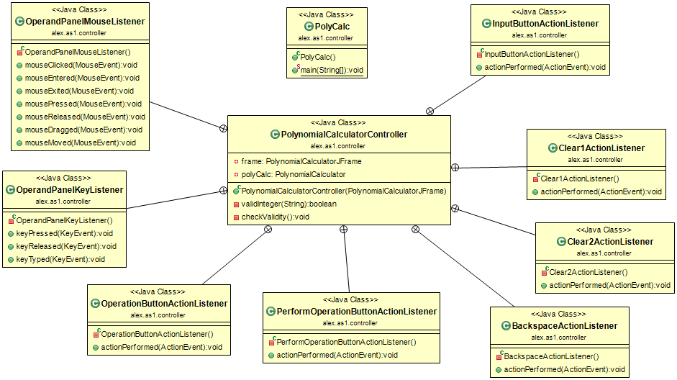
First of all the controller is a holder for the model and the view and represents the bridge between them. It implements all the listeners that get triggered by user input. It contains a PolynomialCalculatorJFrame (the view top level) and a PolynomialCalculator (the model top level).
- GUI and Implementation
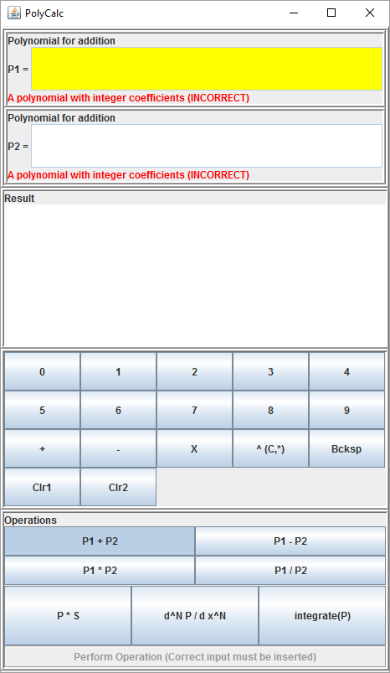
This is the Graphical User Interface of the finished application. The four sections are separated by composite bevel layers (raised one followed by lowered one).
The first panel is represented by two OperandPanels which are used to hold the input. There are two ways to send them input (only one really because they are linked): pressing buttons in the third panel, the InputPanel, and using the keyboard. The valid key buttons represent the buttons in the input panel, in fact input from the keyboard is redirected and eventually call the same methods as if a button was pressed. This way code duplication is avoided.
In order to send input to a specific Operand Panel, the respective panel must be clicked (the TextField part) to be selected, then all input buttons but the Clr buttons will attempt to insert input into the text field. After an input button was pressed, the pre-parsing check takes place: It checks if the last element inserted can precede the one that was just pressed. If it is, then the input is accepted, otherwise nothing happens. For example if a sign was just pressed, you cannot type another sign right after it. After a button was accepted, it performs another check to see if the inserted input is valid, since it has been checked so far, it only needs to check the last element added. For example an input can end with a number: “-2x^2 +1” or “-2x^2” but not with a sign or the exponent marker (caret): “-2x^” or “-2x^2 +”.
If this post-input check passes for both operands, then the Performed Operation Button is enabled. Otherwise it is disabled since the input data does not correspond the format. This way the input is always correct, or can still be correct by pressing moar buttons, thus it is fool-proof.

Entire class diagram
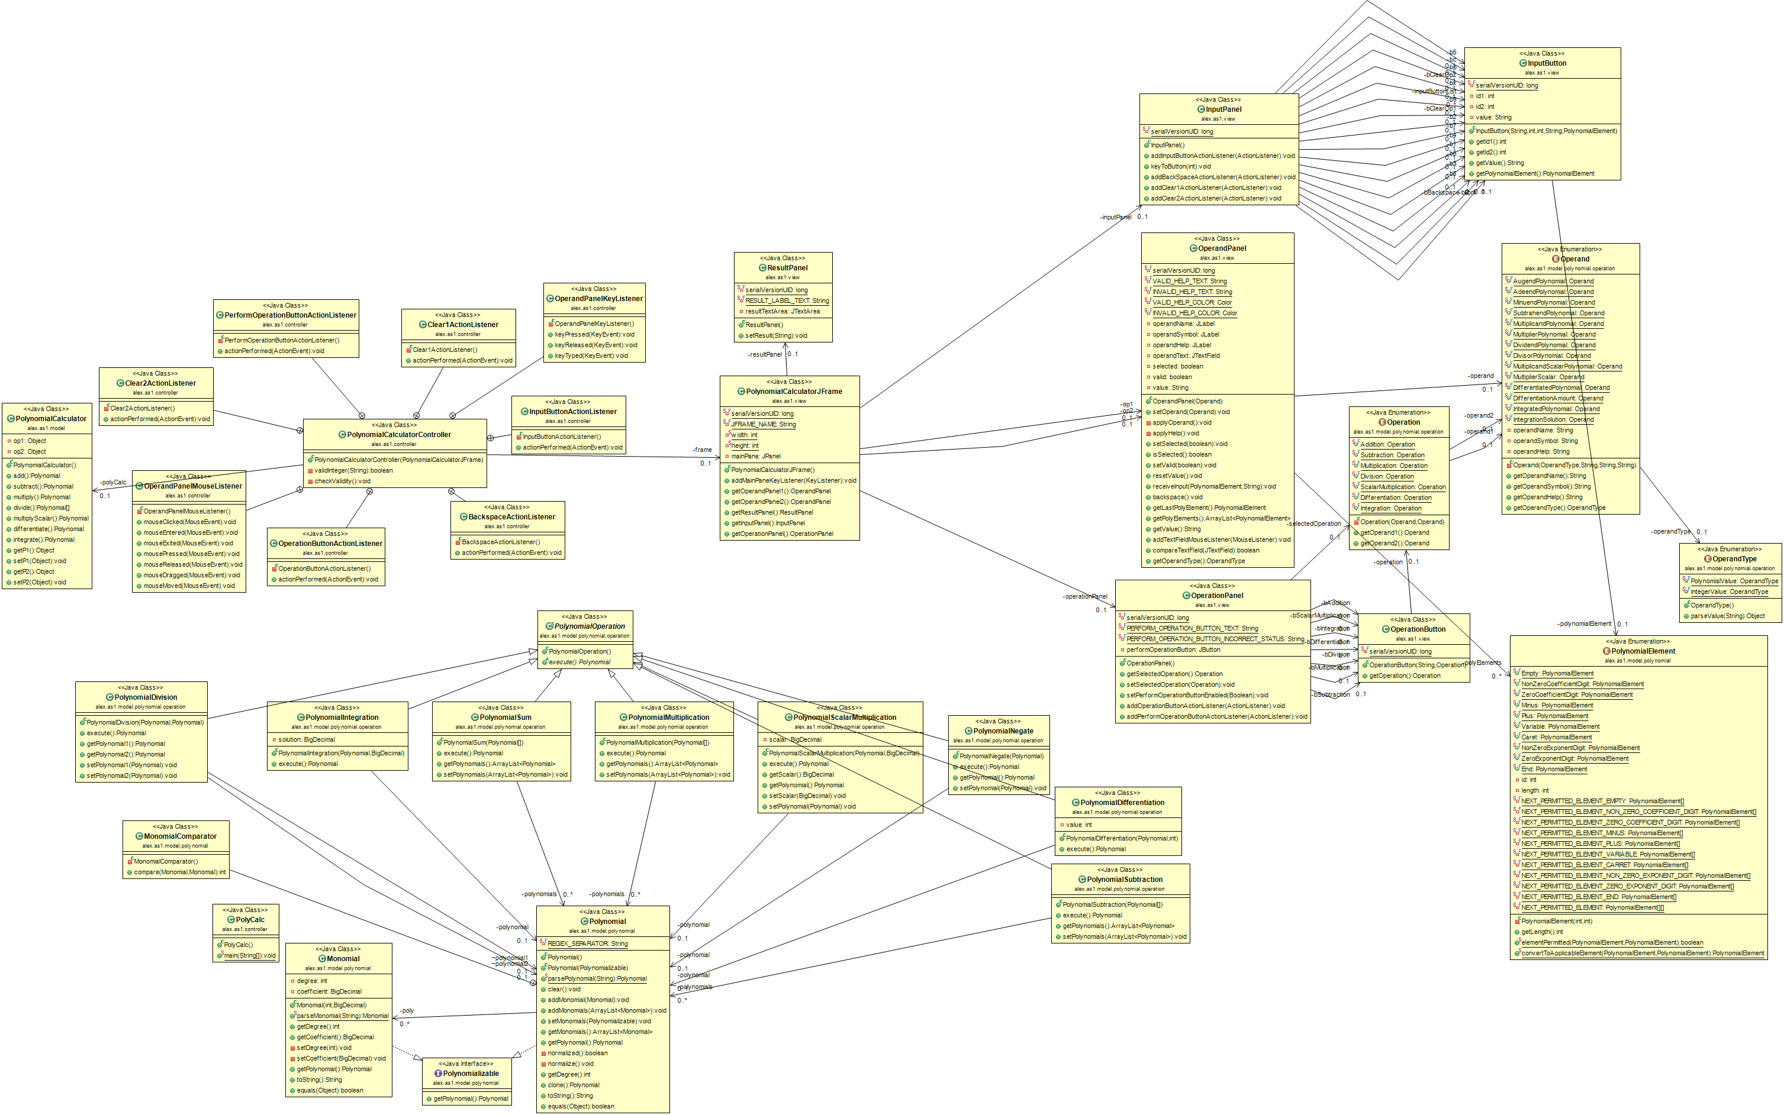
This is the entire class diagram containing all the classes. Note that the operations are used in the top level model class, however there is no strong dependency, since the operation classes are discarded after one use.
Also note that a big part of the model consists of enums that contain data useful to make the design of the controller more compact: having multiple buttons contain data of their own and there being a single listener for all of them: this greatly reduces the amount of code in the controller.
5. Testing
References:
Monomials: https://en.wikipedia.org/wiki/Monomial
Polynomials: https://en.wikipedia.org/wiki/Polynomial
Tools:
IDE: Eclipse IDE
Use case diagram: http://yuml.me/
UML: ObjectAid plugin for Eclipse IDE

